Finding Nearby Wireless Hotspots

Team Members:
Chris Scoville
Tessa MacDuff
Matt Mohebbi
Aiman Erbad
Khalil El Haitami

1. Introduction
Our product is a client application that runs on Smart Phones and PocketPCs which use the Windows Mobile OS and have GPS capabilities. The application provides a list of the ten closest wireless hotspots based on the user’s current location. This list will show the name, location type (café, restaurant, etc) and distance to each of the returned hotspot locations. The user will also have the ability to get driving directions to any of the locations and find out additional information about the hotspot such as the network type and the location’s phone number.

2. Architecture

2.1 The client software

The client software will be very easy to use and straight forward. It will be designed to allow the user to quickly get a list of hotspots without waiting very long for the information. We will use .NET to write the code for the application because we will be programming the software to be run on Windows Mobile. .NET provides support for Windows Mobile software. The software will be able to be loaded on Smart Phones (we do have a smart phone available already) and Pocket PCs (Microsoft donated some pocket PCs to the class for us to work with). The phone and the Pocket PC must have a GPS attachment connected to it for the client software to work. The GPS attachment plugs into the memory compartment on the phone or the Pocket PC. Microsoft said they would probably be able to get us a GPS attachment to use for the project, and if they are not able to get us one, we will emulate one.

2.1.1 Client software UI
The client software UI will consist of two buttons and a title screen to start with. The title screen will read, “Wireless hotspot locator.” One this same page there will be a start button and an exit button. The start button launches the program and the quit button quits the program.
The UI for the rest of the program is also very simplistic. The results will be returned all in text. It will be a list of the ten closest wireless hotspots that the user will be able to scroll through (highlighting each location). The list will contain the location’s name and distance from the user. If the user presses the action key while any of the ten locations are highlighted, then more information will be displayed (in scrollable text) about the selected location. This information will be the location’s name, phone number, address, and whether the connection is free or not. There will also be a button on this screen that will allow the user to get driving directions (displayed in scrollable text) to the hotspot location. A back button will also be available on this screen so that the user can go back to the list of ten hotspots.
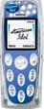
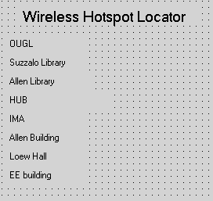
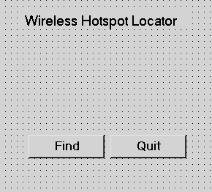
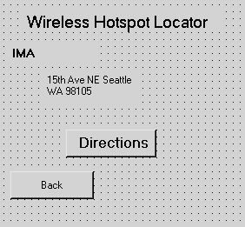
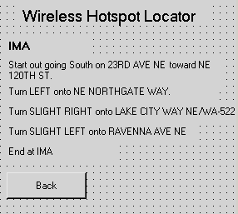
Find
Click IMA
Click Directions

2.1.2 Client software Architecture
When the client application is launched, the first step is getting the GPS location of the user. Next, the client will connect to the server that contains the web service. This GPS location will then be sent to the web service and the web service will return the list of ten locations and the additional information on each location all as text. This text will be formatted in such a way that the client application will read in the text and divide it up into different sections that can be stored in different variables and used if the user wants to view the information. If the user wants driving directions to a location, the client application will connect to the server again and send the GPS location of the user and the address of the location to a different web service than before. This web service will return driving directions in text to the client application. The client application can then display these directions in the proper format for the user to read.

GPS location < X, Y>
<X,Y> ZIP
<X, Y>
Hotspots
ZIP Hotspots
SQL server
<X, Y>
W2
W1
Hotspots
Directions
Directions
Directions
Address
Client
Web Services
Map Point

Figure 1: The overall data flow

2.2 The Backend
The main component in the backend is an SQL server which holds the information about different locations and hot spots. The SQL database will have the information about hotspots organized by their zip code. The interaction with the backend happens through two Web Services.

Web service 1:
It takes in a GPS location (longitude and latitude) and returns a text list of the ten closest hotspot locations along with information about each location. The text can be returned in a 2D array so that the information is organized by each location and so that the client application can easily loop through the data to display it.

Our Web Service will be using a pre-existing database provided by wi-fihotspotlist.com. This database comes in XML format and contains information about wireless hotspots throughout the United States. We will parse the XML file creating a database and the process can be automated by using a script to update our SQL database. Searching through a database should be orders of magnitude faster than searching through the XML file, given the large size of the XML file (approximately 3 MB).

One problem we have to deal with is the different representation of location between the pre-existing database and the GPS unit. The pre-existing database uses zip codes; however, the GPS unit uses the longitude and the latitude as a definition of a location.
The Web Service first finds the zip code for the GPS location. The mapping between locations (longitude, latitude) representation and the zip code representation will be done by the SQL database that was populated by information taken from http://www.chilidog.com/cgiwork/zip.txt . Then the web service will use SQL queries to search the database for locations with the same zip code. We will quickly throw out all addresses that are not reasonably close to this zip code. Next a distance between the GPS location and each remaining hotspot address must be calculated by converting each address to a GPS location and computing the distance between the two locations using the Great Circle Distance Formula. The ten locations with the smallest distances will be saved and returned.

Web service 2:
It takes in a GPS location and a destination address and returns driving directions in text. It will do this by using the Microsoft Map Point service. We will convert the address into a GPS location, and enter the two GPS locations into the Microsoft Map Point service to get the directions. We may even be able to enter all the locations in the database as points of interest in the Map Point service, which would eliminate the step of converting the address into a GPS location. This would simplify and speed up the process.

2.3 Optimization
We plan on minimizing the time the client software is connected to the server. The faster we can query the database, the faster results can be returned.

2.4 Testing
We plan on testing the software with the .NET debugger, which emulates the Windows Mobile software, and we also plan on using the real hardware to test our application and web services. When we are testing the client software with the emulator we will have to emulate the GPS device also, which shouldn’t be a problem because we can use a default GPS location to substitute the location that the GPS device would be returning.

Potential Interface Problem Areas for Testing

Server interface for Client

ListOfLocations getNearByHotspots( Location clientLoc )

Parameter: clientLoc
- null
- impossible/invalid
- very obscure (not close to any hotspots)
- very popular (close to many hotspots)

Return Value
- less than expected number of hotspots (inc. zero/null)
- more than expected number of hotspots
- very long location description (each attribute)
- negative

String getDirections( Location clientLoc, LocationID hotspotID )

Parameter: clientLoc
- null
- impossible/invalid
- very obscure (not close to any hotspots)
- very popular (close to many hotspots)

Parameter: hotspotID
- null
- impossible/invalid (negative, char)
- very close
- very far

Return Value
- null String
- very long string
- strange characters (tab, endl)

Database interface for Server

ListOfLocations getLocations()

Return Value
- less than expected number of hotspots (inc. zero/null)
- more than expected number of hotspots
- very long location description (each attribute)
- negative

String getName( LocationID hotspotID )

Parameter: hotspotID
- null
- not in database
- invalid/impossible

Return Value
- null
- very long
- strange characters

String getType( LocaitonID hotspotID )

Parameter: hotspotID
- null
- not in database
- invalid/impossible

Return Value
- null
- very long
- strange characters

String getAddress( LocationID hotspotID )

Parameter: hotspotID
- null
- not in database
- invalid/impossible

Return Value
- null
- very long
- strange characters

String getPhoneNum( LocationID hotspotID )

Parameter: hotspotID
- null
- not in database
- invalid/impossible

Return Value
- null
- very long
- strange characters

String getPrice( LocationID hotspotID )

Parameter: hotspotID
- null
- not in database
- invalid/impossible

Return Value
- null
- very long
- strange characters

int getRating( LocaitonID hotspotID )

Parameter: hotspotID
- null
- not in database
- invalid/impossible

Return Value
- zero
- invalid (zero, too large)

boolean addRating( LocaitonID hotspotID, int rating )

Parameter: hotspotID
- null
- not in database
- invalid/impossible

Parameter: rating
- zero
- invalid (negative, too large)

Return Value
- true
- false

boolean addHotspot( Location hotspot, String name, String type,
String address, String phoneNum, String price,
int rating )

Parameter: hotspot
- null
- very long
- impossible/invalid
- duplicate
- very close to others
- very far (out of scope?)

Parameter: name
- null
- very long
- impossible/invalid
- duplicate

Parameter: type
- null
- very long
- impossible/invalid
- duplicate

Parameter: address
- null
- very long
- impossible/invalid
- duplicate

Parameter: phoneNum
- null
- very long
- impossible/invalid
- duplicate

Parameter: price
- null
- very long
- impossible/invalid
- duplicate

Parameter: rating
- zero
- invalid (negative, too large)

Return Value
- true
- false

boolean refreshDatabase( String filePathToXML )

Parameter: filePathToXML
- null
- file does not exist
- invalid path (*, ?)
- "."
- ".." ("../../../")

Return Value
- true
- false

